**LOGISTICS CLUSTER**

NATIONAL DISASTER RISK REDUCTION AND MANAGEMENT COUNCIL

**Software Quality Management** | Asia Pacific College A.Y. 2017-2018

**Project Title:**

* NDRRMC – Logistics System

**Project Team:**

* Jimenez, Marc Adrian BSCS-CN Project Manager/ Assistant System Developer
* Abuel, Ferdinand Kenneth BSIT-MI System Developer
* Coronel, Sherine Jane BSCS-SS Documenter/Assistant Quality Assurance Analyst
* Dela Cruz, Joey Bernadette BSCS-CN Assistant Documenter/Quality Assurance Analyst

**Course Instructor:**

* Mr. Edmundo Casiño Project Adviser

**Client Agency:**

* NDRRMC | Office of Civil Defense – Logistics Cluster

**Client Logo:**

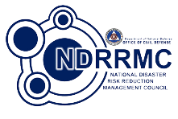

**System Modules:**

* User Management
* Procurement
* Transport

**TABLE OF CONTENTS**

INTRODUCTION 3

DOCUMENT PURPOSE 3

SYSTEM OVERVIEW 3

QUALITY OBJECTIVES 3

OVERALL FRAMEWORK DESIGN 3

PROJECT TEAM MEMBERS & USER IDENTIFICATION 4

QUALITY ASSURANCE PROCESS 5

# **INTRODUCTION**

This paper focuses on the Software Quality Assurance of the project, NDRRMC – Logistics System, which was developed to ensure that the project to be delivered is in utmost quality. The target users of this project are the different admins of each City Municipal, Province, Region the 12 different clusters of NDRRMC, including the Logistics Cluster which is headed by the Office of Civil Defense (OCD).

This document will serve as the basis to see if the proposed web application ensures that the modules and processes of the system are free from issues and errors, is fully functional, and complete.

# **DOCUMENT PURPOSE**

This Software Quality Assurance Plan is intended to ensure that the system developed for the Logistics Cluster of NDRRMC will meet the requirements proposed to them, free from issues and bugs, data are secured, modules are working well, and overall complete. Included also in this paper are the Checklist of the different submodules and the test cases of the three (3) major modules namely, User Management, Procurement, and Transportation.

# **SYSTEM OVERVIEW**

The NDRRMC - Logistics System was developed using a PHP based web framework called Yii2, which includes out-of-the-box modules for quicker and rapid development. Since it is a web application, the language used to write the software is PHP; HTML and CSS were also used to create the web application. The system is hosted using an EC2 instance, which is a cloud service by Amazon Web Services. For the database of the system, an open source database called MariaDB was the selected database, PhpMyAdmin was also used to easily administer the database due to the Graphical User Interface.

# **QUALITY OBJECTIVES**

The Software Quality Assurance that the team proposed intends to make sure that the system can be used easily by the different users, can handle simultaneous requests to the same resource, can be accessed through web without encountering any errors, can secure its data, and can carry out the system’s purpose. These will be possible through applying the principles of Agile Testing, which then follows the process of Agile Software Development. The Agile Testing principles in relation to the NDRRMC—Logistics System are the following: the team shall prioritize the client’s satisfaction, regular collaboration with the client, immediate response to change, continuous improvement, maximized amount of work, and provide a fully-functional system. (Software Testing Fundamentals, n.d.)

# **OVERALL FRAMEWORK DESIGN**

The diagram below represents the framework design of the system, it visually explains how the system and the users are connected to one another. The Logistics System is accessible through a web browser (ex: Google Chrome) as long as the user has an active internet connection since the website is hosted via cloud. Cloud web hosting is a service that the project team used to deploy the system through the Internet. Inside the cloud environment are the three major system modules which are the User Management, Transport, and Procurement. The User Management module handles the different users that the system caters to namely Regional Admin, Provincial Admin, City Municipal Admin, and the External Users which consists of the 12 different cluster members of the NDRRMC. The Transport module mainly revolves on the movement of the resources; it provides the available list of vehicles that can be used to travel from one place to another. Lastly, the Procurement module is responsible of keeping track of the current resources each warehouse has, as well as where they are acquired from, and the requesting of the said resources by the users. These modules are connected to the database called MariaDB which contains all the records that are essential for the system.

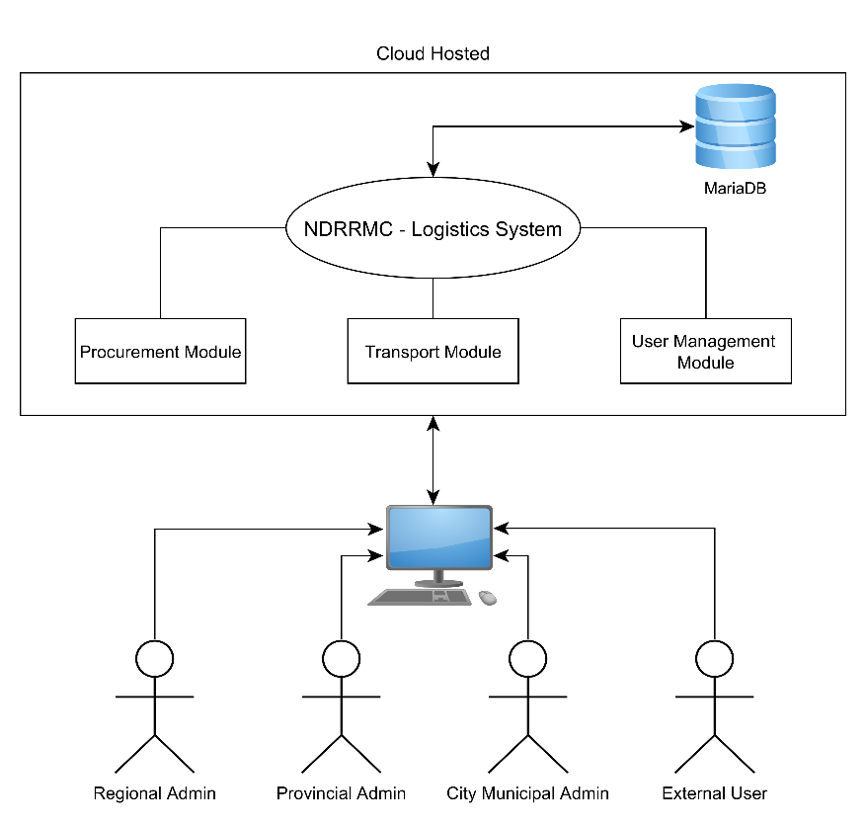

# **PROJECT TEAM MEMBERS & USER IDENTIFICATION**

| MEMBER | ROLE | RESPONSIBILITIES |
| --- | --- | --- |
| NDRRMC – Logistics Cluster | * Client | As the client of this project, they are responsible on giving the Project Team the requirements to fulfill and the current process that they have. |
| Regional Admin, Provincial Admin, City Municipal Admin, Member Agencies of NDRRMC | * Users | As the Users of the system, they are responsible on alpha and beta testing the system before its release. |
| MARC ADRIAN JIMENEZ | * Project Manager * Assistant System Developer | As the Project Manager, he is responsible for monitoring the progress of the team, as well as assist the team in creating test plans and testing efforts  As the Assistant System Developer, he is responsible for helping the system developer. |
| FERDINAND KENNETH ABUEL | * System Developer | As the System Developer, he is responsible for writing, modifying, and debugging the system. |
| SHERINE JANE CORONEL | * Documenter * Assistant Quality Assurance Analyst | As the Documenter, she is responsible to review the documents for consistency, as well as to maintain the version control of all the documents.  As the Assistant Quality Assurance Analyst, she is responsible for helping the Quality Assurance Analyst. |
| JOEY BERNADETTE DELACRUZ | * Quality Assurance Analyst * Assistant Documenter | As the Quality Assurance Analyst, she is responsible for designing test plans and scenarios, as well as analyzing, interpreting and communicating qualitative and quantitative findings from tests.  As the Assistant Documenter, she is responsible for helping the Documenter. |

# **QUALITY ASSURANCE PROCESS**

To assess the quality of the system, the project team prepared a check-list of the functionalities of the modules and several test cases for each module.